**PRACTICAL- 2**

**Aim:** Use of Ping and Tracert / Traceroute and Arp Utilities.

*Diagnostic commands* help you detect TCP/IP networking problems. Some of the diagnostic commandsare **arp**, **hostname**, **ipconfig, netstat**, **ping**, **route**, and **tracert.**

1. **arp**

* This diagnostic command displays and modifies the IP-to-Ethernet or Token Ring physical address translation tables used by the Address Resolution Protocol (ARP).
* **Syntax**

**arp -a** [inet_addr] [**-N** [if_addr]]**arp -d**inet_addr [if_addr]

**arp -s**inet_addrether_addr [if_addr]

* **Parameters** 
  + **-a** Displays current ARP entries by querying TCP/IP. If*inet_addr*is specified, only the IP andphysical
  + Addresses for the specified host are displayed.
  + **-d** Deletes the entry specified by*inet_addr*
  + **-s** adds an entry in the ARP cache to associate the IP address*inet_addr*with the physical address*ether_addr*.
  + The physical address is given as 6 hexadecimal bytes separated by hyphens. The IP address is specified using dotted decimal notation. The entry is static. It will not be automatically removed from the cache after the timeout expires and will not exist after a reboot of your computer.

**-N [*if_addr*]** Displays the ARP entries for the network interface specified by*if_addr*.***ether_addr***Specifies a physical address. ***if_addr*** Specifies, if present, the IP address of the interface whose address translation table should be modified. If not present, the first applicable interface will be used. ***inet_addr*** Specifies an IP address in dotted decimal notation.

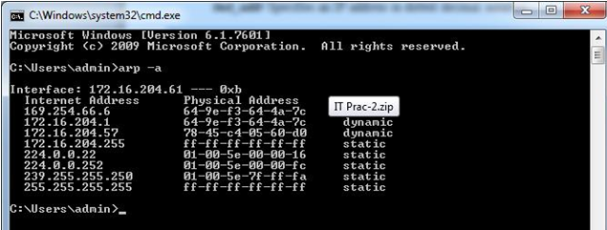

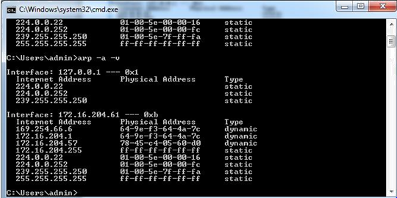

1. **hostname**

* This diagnostic command prints the name of the host on which the command is used.
* **Syntax**

**hostname --** This command has no parameters.

1. **ipconfig**

* This diagnostic command displays all current TCP/IP network configuration values. This command is useful on computers running DHCP because it enables users to determine which TCP/IP configuration values have been configured by DHCP. If you enter only **ipconfig**without parameters, the response is a display of all of the current TCP/IP configuration values, including IP address, subnet mask, and default gateway.
* **Syntax**

**ipconfig**[**/all** | **/renew** [*adapter*] | **/release** [*adapter*]]

* **Parameters** 
  + **all**Produces a full display. Without this switch,**ipconfig**displays only the IP address, subnetmask, and default gateway values for each network card.
  + **renew [*adapter*]** Renews DHCP configuration parameters. This option is available only oncomputers running the DHCP Client service. To specify an adapter name, type the adapter name that appears when you use **ipconfig** without parameters.

**release [*adapter*]** Releases the current DHCP configuration. This option disables TCP/IP on thelocal computer and is available only on DHCP clients. To specify an adapter name, type the adapter name that appears when you use **ipconfig** without parameters.

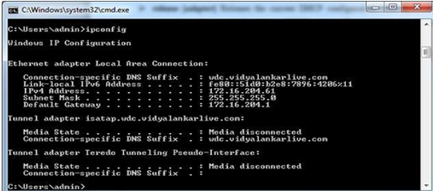

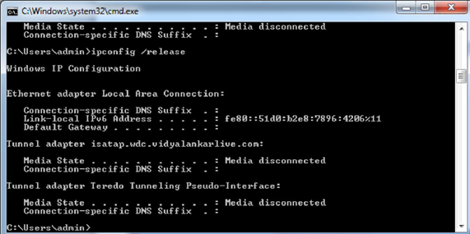

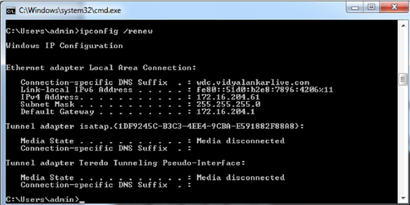

1. **netstat**

* This diagnostic command displays protocol statistics and current TCP/IP network connections.
* **Syntax**

**netstat**[**-a**] [**-e**][**-n**][**-s**] [**-p** *protocol*] [**-r**] [*interval*]

* **Parameters** 
  + **-a** Displays all connections and listening ports; server connections are usually not shown. **-e** Displays Ethernet statistics. This can be combined with the **-s** option. **-n** Displays addresses and port numbers in numerical form (rather than attempting name lookups). **-s** Displays per-protocol statistics. By default, statistics are shown for TCP, UDP, ICMP, and IP; the **-p** option can be used to specify a subset of the default.
  + **-p *protocol***Shows connections for the protocol specified.
  + **-r** Displays the contents of the routing table.

***Interval*** Redisplays selected statistics, pausing*interval*seconds between each display.

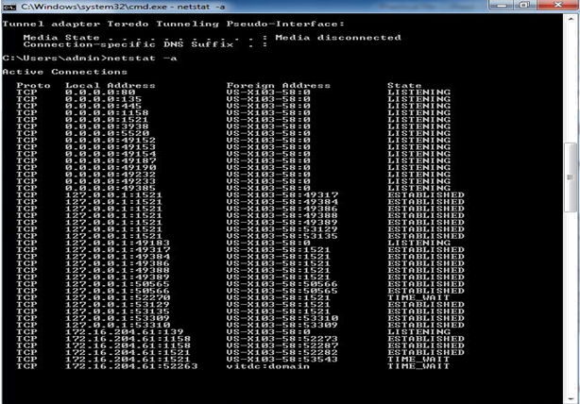

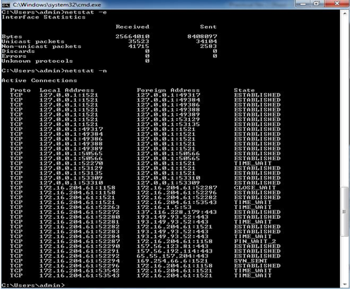

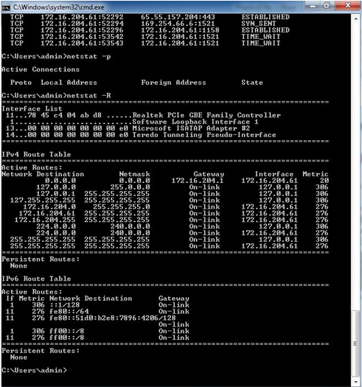

1. **ping**

* This diagnostic command verifies connections to one or more remote computers.
* **Syntax**

**ping**[**-t**] [**-a**] [**-n** *count*] [**-l** *length*] [**-f**] [**-i** *ttl*] [**-v** *tos*] [**-r** *count*] [**-s** *count*][[**-j***host-list*] | [**-k***host-list*]] [**-w***timeout*] *destination-list*

* **Parameters** 
  + **-t** Pings the specified host until interrupted.
  + **-a** Resolves addresses to host names.
  + **-n *count***Sends the number of ECHO packets specified by*count*. The default is 4.
  + **-l *length***Sends ECHO packets containing the amount of data specified by*length*. The default is64 bytes; the maximum is 8192.
  + **-f** Sends a Do Not Fragment flag in the packet. The packet will not be fragmented by gateways onthe route.
  + **-i*ttl***Sets the time to live field to the value specified by*ttl*.
  + **-v *tos***Sets the type of service field to the value specified by*tos*.
  + **-r *count***Records the route of the outgoing packet and the returning packet in the record routefield. A minimum of 1 to a maximum of 9 hosts must be specified by *count*.
  + **-s *count***Specifies the timestamp for the number of hops specified by*count*.
  + **-j *host-list***Routes packets via the list of hosts specified by*host-list*. Consecutive hosts can beseparated by intermediate gateways (loose source routed). The maximum number allowed by IP is 9.
  + **-k *host-list***Routes packets via the list of hosts specified by*host-list*. Consecutive hosts cannot beseparated by intermediate gateways (strict source routed). The maximum number allowed by IP is 9.
  + **-w *timeout***Specifies a timeout interval in milliseconds.

***destination-list***Specifies the remote hosts to ping.

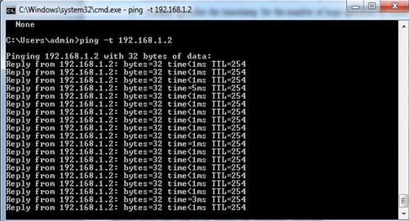

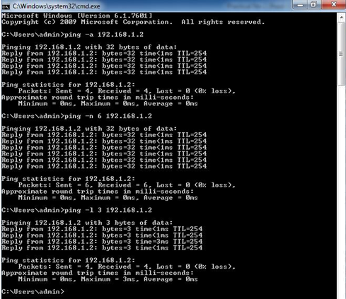

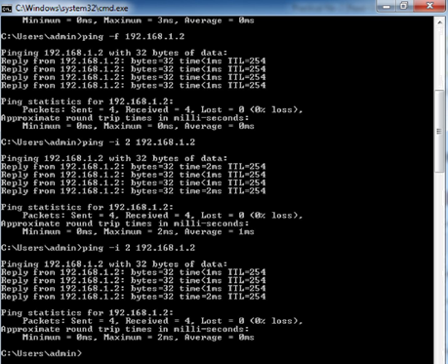

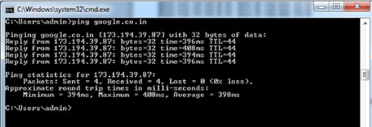

1. **route**

* This diagnostic command manipulates network routing tables.
* **Syntax**

**route**[**-f**] [*command*[*destination*] [**MASK** *netmask*] [*gateway*] [METRIC*metric*]]

* **Parameters** 
  + **-f** Clears the routing tables of all gateway entries. If this parameter is used in conjunction with oneof the commands, the tables are cleared prior to running the command.
  + ***command***Specifies one of four commands.

|  |  |  |  |  |  |
| --- | --- | --- | --- | --- | --- |
|  |  | Command |  | Purpose |  |
|  |  |  |  |  |  |
|  |  | print |  | Prints a route |  |
|  |  |  |  |  | |
|  |  | add |  | Adds a route | |
|  |  |  |  |  | |
|  |  | delete |  | Deletes a route |  |
|  |  |  |  |  | |
|  |  | change |  | Modifies an existing route | |
|  |  |  |  |  |  |

* ***destination***Specifies the host to send*command*.
* **MASK** Specifies, if present, that the next parameter be interpreted as the*netmask*parameter.
* ***netmask***Specifies, if present, the subnet mask value to be associated with this route entry. If notpresent, this parameter defaults to 255.255.255.255.
* ***gateway***Specifies the gateway.
* **METRIC** Specifies the route metric (cost) for the destination.

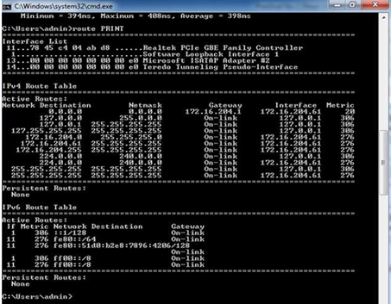

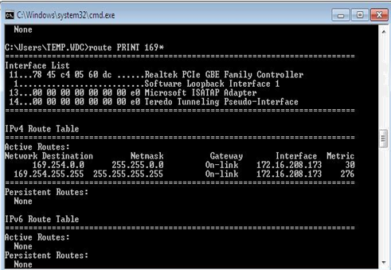

1. **tracert**

* This diagnostic utility determines the route taken to a destination by sending Internet Control Message Protocol (ICMP) echo packets with varying time-to-live (TTL) values to the destination. Each router along the path is required to decrement the TTL on a packet by at least 1 before forwarding it, so the TTL is effectively a hop count. When the TTL on a packet reaches 0, the router is supposed to send back an ICMP Time Exceeded message to the source computer.
* **Tracert**determines the route by sending the first echo packet with a TTL of 1 and incrementing theTTL by 1 on each subsequent transmission until the target responds or the maximum TTL is reached. The route is determined by examining the ICMP Time Exceeded messages sent back by intermediate routers. Notice that some routers silently drop packets with expired TTLs and will be invisible to **tracert**.
* **Syntax**

**tracert**[**-d**] [**-h** *maximum_hops*] [**-j** *host-list*] [**-w** *timeout*]*target_name*

* **Parameters** 
  + **-d** Specifies not to resolve addresses to host names.
  + **-h *maximum_hops***Specifies maximum number of hops to search for target.
  + **-j *host-list***Specifies loose source route along*host-list*.
  + **-w *timeout***Waits the number of milliseconds specified by*timeout*for each reply.

***target_name***Name of the target host.

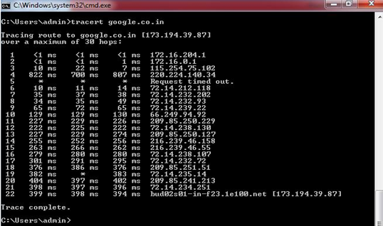

**PRACTICAL-3**

**Aim :** To Configure IP static routing.

Theory :





**Example-3.1**

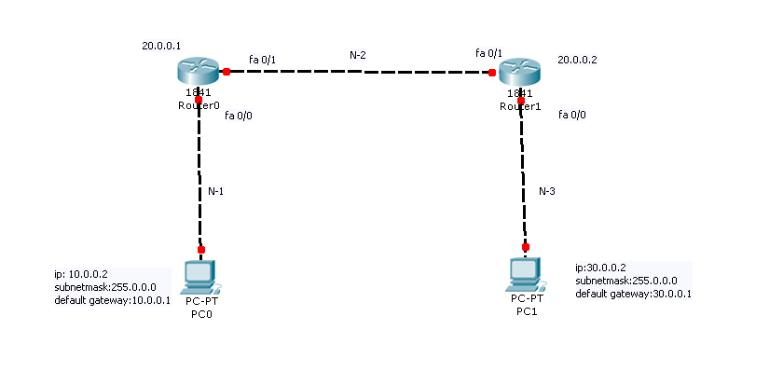

**Assign IP address, subnet mask and default gateway to PC0**

Double click on “PC-PT” i.e PC0 🡪 Desktop 🡪 IP Configuration 🡪 Static 🡪 set the fields.

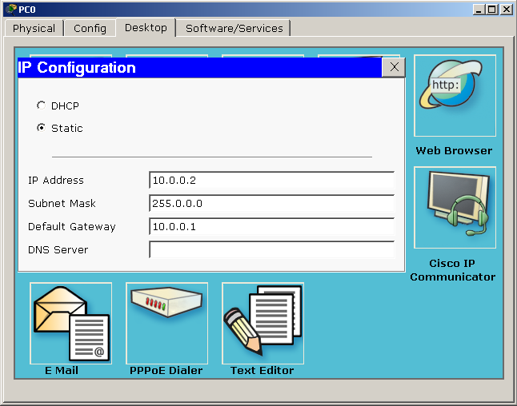

**Assign IP address, subnet mask and default gateway to PC1**

Double click on “PC-PT”i.e PC1🡪 Desktop 🡪 IP Configuration 🡪 Static 🡪 set the fields.

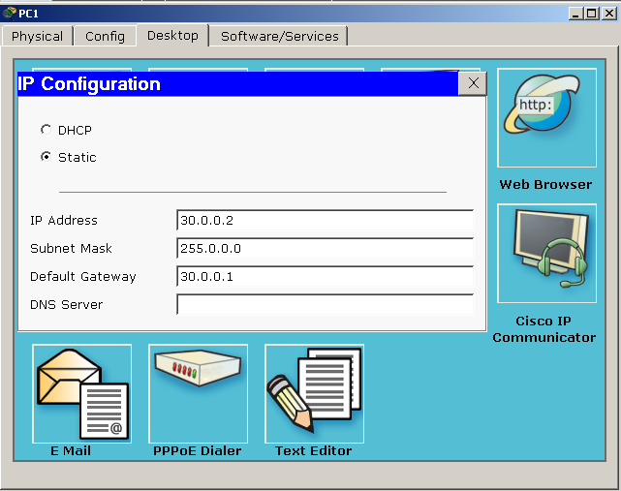

**Configure Router0**

Router>enable

Router#configure terminal

Enter configuration commands, one per line. End with CNTL/Z.

Router(config)#host R0

R0(config)#interfacefastethernet0/0

R0(config-if)#ip address 10.0.0.1 255.0.0.0

R0(config-if)#no shutdown

R0(config-if)#exit

R0(config)#interface fastethernet 0/1

R0(config-if)#ip address 20.0.0.1255.0.0.0

R0(config-if)#no shutdown

R0(config-if)#exit

R0(config)#exit

R0#

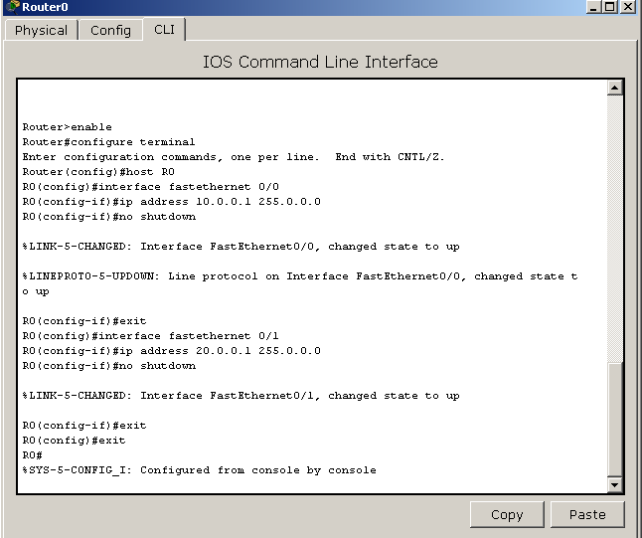

**Configure Router1**

Router>enable

Router#configure terminal

Enter configuration commands, one per line. End with CNTL/Z.

Router(config)#host R1

R1(config)#interfaceFastEthernet0/0

R1(config-if)#ip address 30.0.0.1 255.0.0.0

R1(config-if)#no shutdown

R1(config-if)#exit

R1(config)#interface fastethernet 0/1

R1(config-if)#ip address 20.0.0.2 255.0.0.0

R1(config-if)#no shutdown

R1(config-if)#exit

R1(config)#exit

R1#

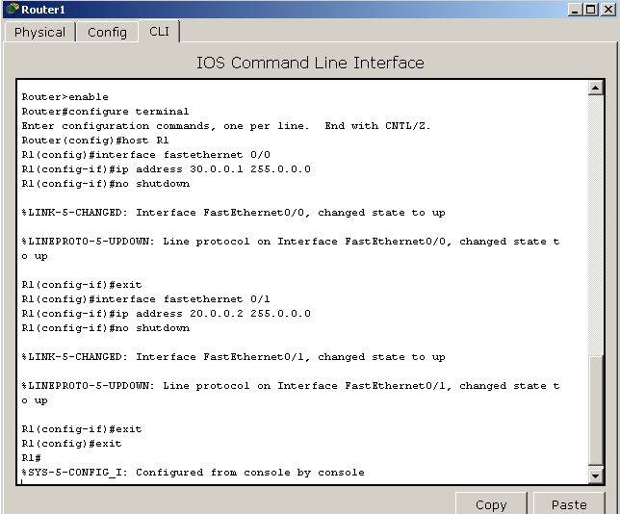

**After 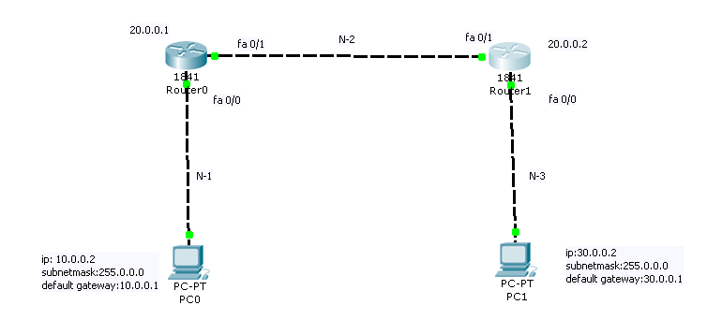Configuration**

Now right click on PC 0 and go to Command Prompt

**Ping from PC0 to R0 interface0/0 (10.0.0.2)**

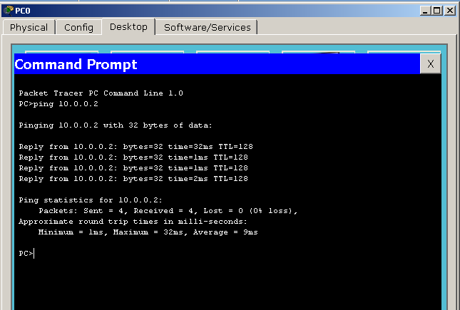

**Ping from PC0 to R0 interface 0/1 (20.0.0.1)**

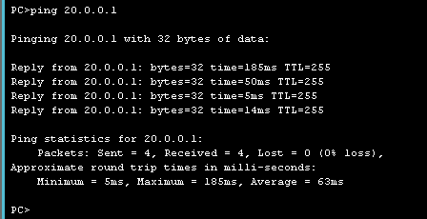

**Ping from PC0 to R1 interface 0/1 (20.0.0.2)**

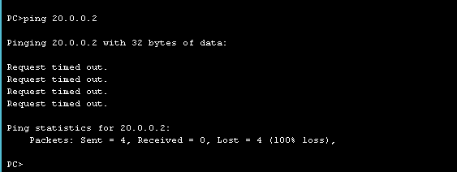

**So assign static route to R1.**

R1#config t

R1 (config) #ip route 10.0.0.0 255.0.0.0 20.0.0.1

R1 (config) #

**Now again Ping from PC0 to R1 interface 0/1(20.0.0.2)**

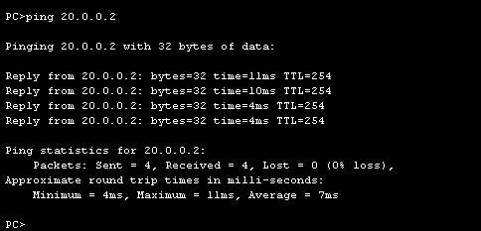

**Ping from PC0 to R1 interface 0/0(30.0.0.2)**

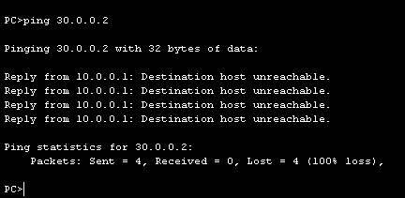

**so assign static route to R0**

R0 (config) #ip route 30.0.0.0 255.255.255.0 20.0.0.2

R0 (config) #

**Now again ping from PC0 to R1 interface 0/0(30.0.0.2)**

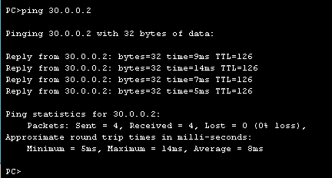

**Ping from PC0 to PC1 (30.0.0.1**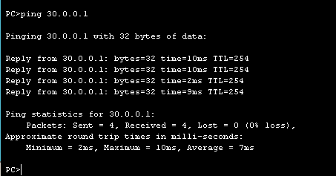

**To see R0 routing table**

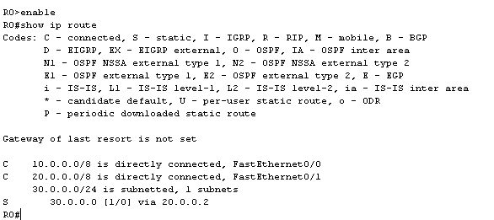R0#show ip route

**To see R1 routing table**

R1#show ip route

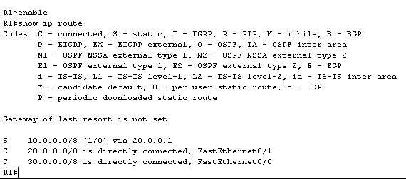

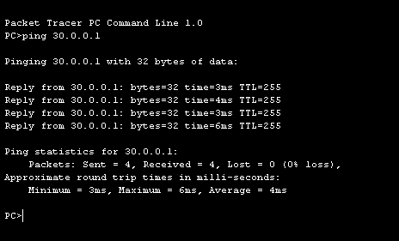**Ping from PC1 to R1 interface 0/0(30.0.0.1)**

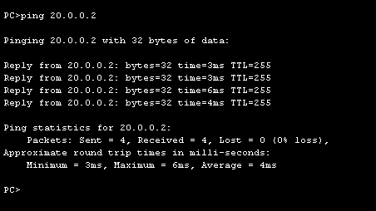**Ping from PC1 to R1 interface 0/1(20.0.0.2)**

**Ping from PC1 to R0 interface 0/1(20.0.0.1)**

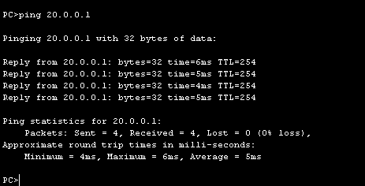

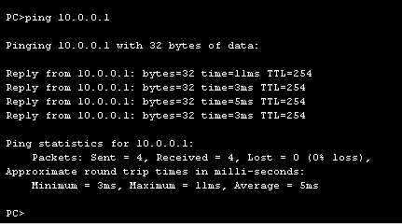**Ping from PC1 to R1 interface 0/0(10.0.0.1)**

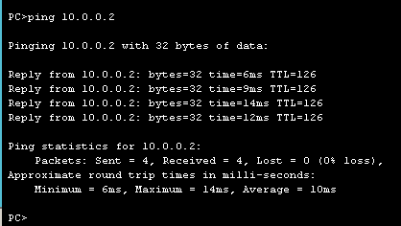**Ping from PC1 to PC0**

**EXAMPLE 3.2**

**Network: 172.16.0.0/16, 192.168.0.0/24,10.0.0.0/8**

**Gateway Address: 172.16.0.1/16, 192.168.0.1/24, 10.0.0.1/8**



**Assign IP addresses, Subnet mask and default gateway to three PCS**

**Click PC1/Desktop/IP configuration/Static**

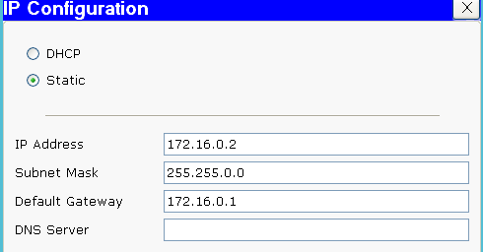

**Click PC2/Desktop/IP configuration/Static**

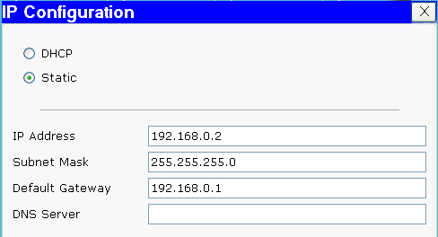

**Click PC3/Desktop/IP configuration/Static**

**Configure Router R1**

Router>enable

Router#configure terminal

Enter configuration commands,one per line.End with CNTL/Z

Router(config)#host R1

R1(config)#interface fastethernet1/0(0/1)

R1(config-if)#ip address 172.16.0.1 255.255.0.0

R1(config-if)#no shutdown

R1(config-if)#exit

R1(config)# interface fastethernet 0/0

R1(config-if)#ip address 100.0.0.1 255.255.255.252

R1(config-if)#no shutdown

R1(config-if)#exit

R1(config)#interface fastethernet 6/0

R1(config-if)#ip address 192.168.0.1 255.255.255.0

R1(config-if)#no shutdown

R1(config-if)#exit

R1(config)#exit

R1#

**Configure Router R2**

Router>enable

Router#configure terminal

Enter configuration commands,one per line.End with CNTL/Z

Router(config)#host R2

R2(config)#interface fastethernet 0/0

R2(config-if)#ip address 100.0.0.2 255.255.255.252

R2(config-if)#no shutdown

R2(config-if)#exit

R2(config)# interface fastethernet1/0(0/1)

R2(config-if)#ip address 10.0.0.1 255.0.0.0

R2(config-if)#no shutdown

R2(config-if)#exit

R2(config)#exit

R2#

**Configure static route to R1**

Go to config mode, type **ip route**command, the subnet number, followed by the mask, and next hop ipaddress.

R1#config t

R1(config)#ip route 10.0.0.0 255.0.0.0 100.0.0.2

R1(config)#

**To see routing table of R1**

R1#show ip route

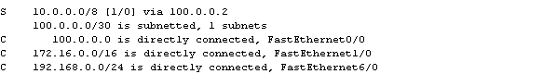

**Configure static route to R2**

R2#config t

R2(config)#ip route 172.16.0.0 255.255.0.0 100.0.0.1

R2(config)#

R2(config)#ip route 192.168.0.0 255.255.255.0 100.0.0.1

R2(config)#

**To see routing table of R2**

R2#show ip route

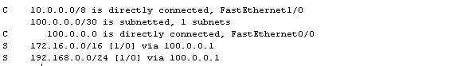

**After assigning ip static route to both the routers PC’s connectivity can be checked using ping command**

**Ping from PC1 to R0 fastethernet 1/0(172.16.0.1)**

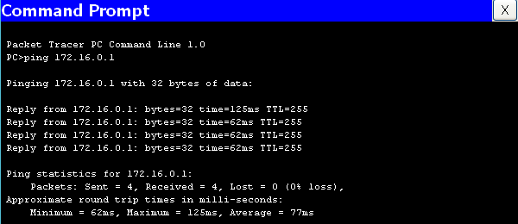

**Ping from PC1 to R0 fastethernet 0/0(100.0.0.1)**

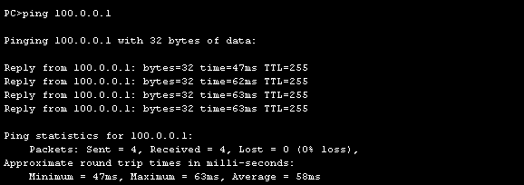

**Ping from PC1 to R0 fastethernet 6/0(192.168.0.1)**

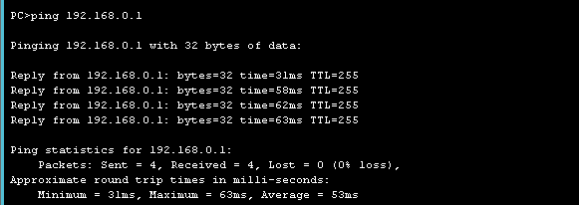

**Ping from PC1 to PC2**

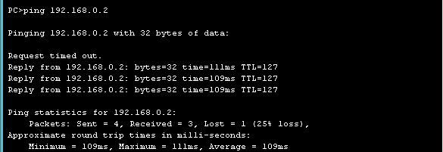

**Ping from PC1 to R1 fastethernet 0/0(100.0.0.2)**

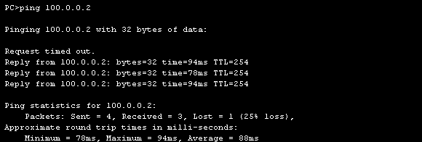

**Ping from PC1 to R1 fastethernet 1/0(10.0.0.1)**

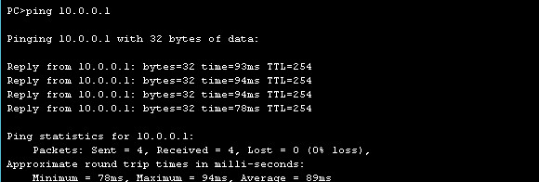

**Ping from PC1 to PC3**

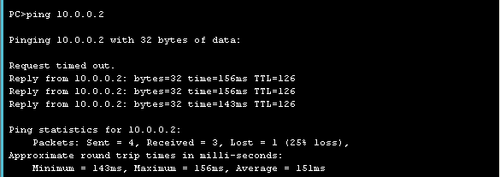

**Ping from PC2 to PC3**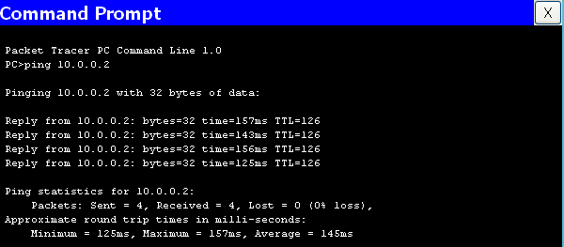

**Ping from PC3 to PC2**

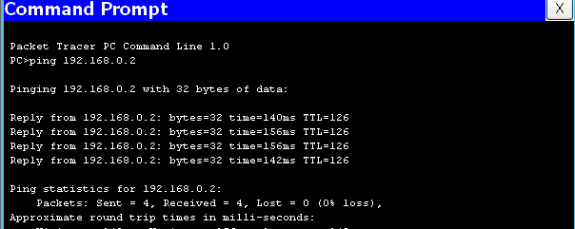

**Ping from PC3 to PC1**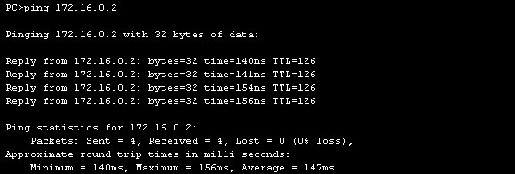

**PRACTICAL-4**

**Aim:** Configure IP routing using RIP

**Theory :** There are two versions of RIP: RIPv1 and RIPv2.

Comparision between RIPv1 and RIPv2

* Both RIPv1 and RIPv2 have the **Administrative distance** 120.
* Both RIPv1 and RIPv2 are distance vector routing protocol.Both RIPv1 and RIPv2’s metric is hop count.Maximum hop count = 15. Max routers = 16.
* Both RIPv1 and RIPv2 send routing updates or complete routing table or broadcast every 30 seconds. i.e. The default routing update period for both version of RIP is 30 seconds. i.e. Both have the same timers.
* Both RIPv1 and RIPv2 use split horizon to prevent routing loops.
* Both RIPv1 and RIPv2 are configured with router rip

**Difference**

* RIPv1 used broadcast. RIPv2 used multicast(224.0.0.9).
* RIPv1 is a classful.(Classful: all subnet mask must be the same in the network.) RIPv2 is a classless.
* RIPv1 does not allow authentication. RIPv2 allows MD5 authentication
* RIP enabled interfaces **send** version 1(RIPv1) updates.Do not send version 2(RIPv2) updates.RIP enabled interfaces **receive** any version(RIPv1 and RIPv2).
* RIPv2 sends the subnet mask in updates and RIPv1 does not. i.e. Subnet mask information is included in RIPv2 routing updates that is not included in RIPv1.

**Advantage of RIPv2 over RIPv1**

* RIPv2 supports MD5 authentication for routing updates. i.e. RIP version 2 supports routing update authentication.
* RIPv2 used multicast(224.0.0.9) rather than broadcast.
* RIPv2 is **classless** routing protocol means that it sends subnet mask information when updates.By sending the subnet mask information with the updates, RIPv2 can support Variable Length Subnet Mask(VLSMs).

**Disadvantage of RIPv1 and RIPv2**

* Both RIPv1 and RIPv2 send full routing tables out every 30 seconds. It’s a lot of overhead, require too much bandwidth. Sending full routing table is unnecessary.
* RIPv1 and RIPv2 does not form adjacency.
* RIPv1 and RIPv2 work only on hop count

**Configure RIPv1 on Cisco Routers with following information:**

Network: 172.16.0.0/16, 192.168.0.0/24, 10.0.0.0/8

Gateway Address: 172.16.0.1/16, 192.168.0.1/24, 10.0.0.1/8



**Assign IP addresses,subnet mask and default gateway to three PCs**

**Click PC1/Desktop/IP configuration/Static**



**Click PC2/Desktop/IP configuration/Static**



**Click PC3/Desktop/IP configuration/Static**

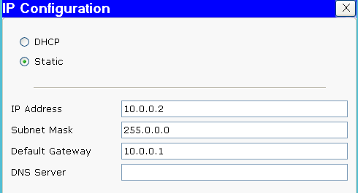

**Configure Router R1**

Router>en

Router#config t

Enter configuration commands,one per line.End with CNTL/Z

Router(config)#host R1

R1(config)#interface fastethernet 1/0

R1(config-if)#ip address 172.16.0.1 255.255.0.0

R1(config-if)#no shutdown

R1(config-if)#exit

R1(config)# interface fastethernet 0/0

R1(config-if)#ip address 100.0.0.1 255.255.255.252

R1(config-if)#no shutdown

R1(config-if)#exit

R1(config)#interface fastethernet 6/0

R1(config-if)#ip address 192.168.0.1 255.255.255.0

R1(config-if)#no shutdown

R1(config-if)#exit

R1(config)#exit

R1#

**Configure Router R2**

Router>en

Router#config t

Enter configuration commands,one per line.End with CNTL/Z

Router(config)#host R2

R2(config)#interface fastethernet 0/0

R2(config-if)#ip address 100.0.0.2 255.255.255.252

R2(config-if)#no shutdown

R2(config-if)#exit

R2(config)# interface fastethernet 1/0

R2(config-if)#ip address 10.0.0.1 255.0.0.0

R2(config-if)#no shutdown

R2(config-if)#exit

R2(config)#exit

R2#

**Configure RIPv1 to router R1Here we put all three network those are connected to R1 router.**

R1(config)#router rip

R1(config-router)#network 172.16.0.0

R1(config-router)#network 192.168.0.0

R1(config-router)#network 100.0.0.0

R1(config-router)#exit

R1(config)#exit

R1#

**Configure RIPv1 to router R2. Here we put all three network those are connected to R2 router.**

R2(config)#router rip

R2(config-router)#network 100.0.0.0

R2(config-router)#network 10.0.0.0

R2(config-router)#exit

R2(config)#

R2#

**See routing table of R1**

R1#show ip route

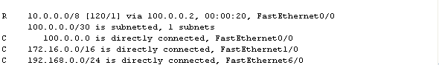

R#showip rip database

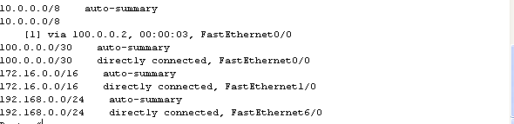

**See routing table of R2**

R2#show ip route

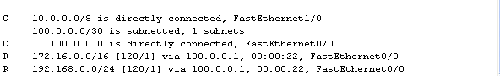

R2#show ip rip database

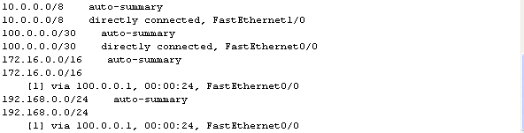

**Check IP connectivity**

Click PC-1/ **Desktop/Command Prompt**

**Ping from PC1 to PC2(192.168.0.2)**

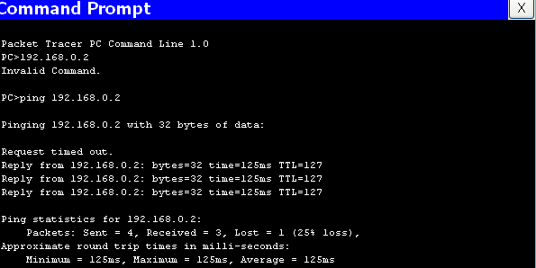

**Ping from PC1 to PC3(10.0.0.2)**

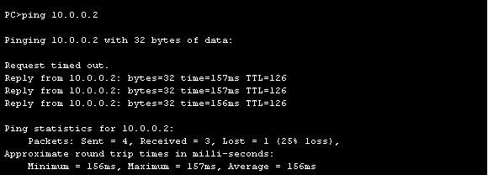

**Ping from PC2 to PC1(172.16.0.2)**

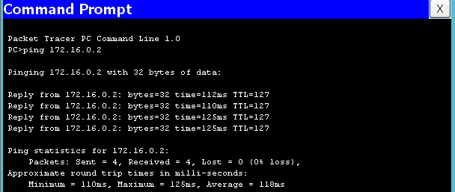

**Ping from PC2 to PC3(10.0.0.2)**

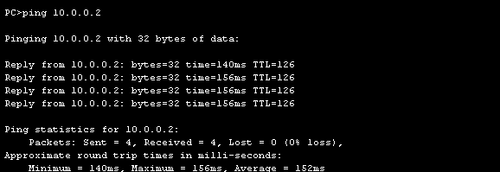

Ping from PC3 to PC1(172.16.0.2)

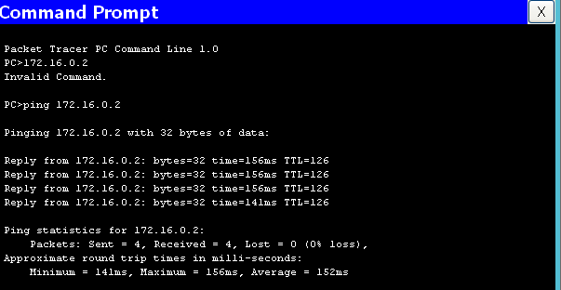

**Ping from PC3 to PC2(192.168.0.2)**

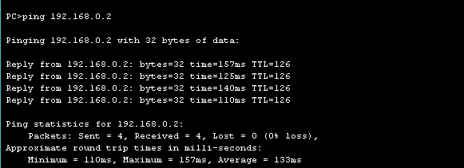

**RIP Commands**

* The command **show ip route** followed by the protocol will show that protocol's route from the entire routing table.

R1#**show ip route rip**

* The command **show protocols** is used to view the RIP routing protocol settings and configuration.
* The command **show ip rip database** will display RIP routing updates or RIP routing information as they are sent and received. But to see the updates in real time, we need command **Debug** not **Show**.But don't do **debug ip rip**, don't do **debug all**. It may crash your router.Because all possible debugs will start and consume router's whole processing and memory.
* The command **debug ip rip** shows the routes being advertised in RIP updates and the metrics of these routes. i.e. **debug ip rip** will display RIP activity as it occurs on a router.

R1#**debug ip rip**

* The command **clear ip route \*** should apply after the command **debug ip rip** to clear the routing table of its dynamic routes.

R1#**clear ip route \***

* The command **undebug all** turn off all debugs.

R1#**undebug all**

* To turn off specific debugs, run the command **no debug** followed by the type of debug you want to turn off.

R1#**no debug ip rip**

**PRACTICAL-5**

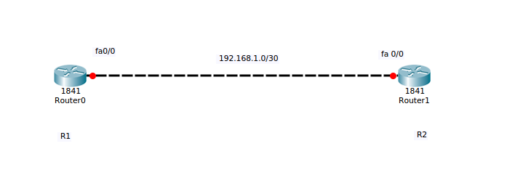**Aim:** Configuring OSPF.

**CONFIGURE ROUTER R1**

Router>en

Router#conf t

Router (config) #host R1

R1 (config) #int f0/0

R1 (config-if) #ip add 192.168.1.1 255.255.255.252

R1 (config-if) #no shut

R1 (config-if) #exit

R1 (config) #

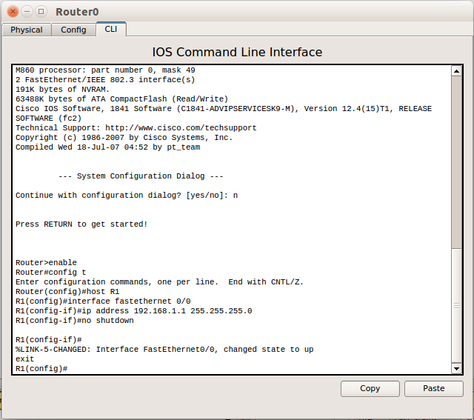

**CONFIGURE ROUTER R2**

Router>en

Router#conf t

Router (config) #host R2

R2 (config) #int f0/0

R2 (config-if)#ip add

R2 (config-if) #ip address 192.168.1.2 255.255.255.252

R2 (config-if) #no shut

R2 (config-if) #exit

R2 (config) #

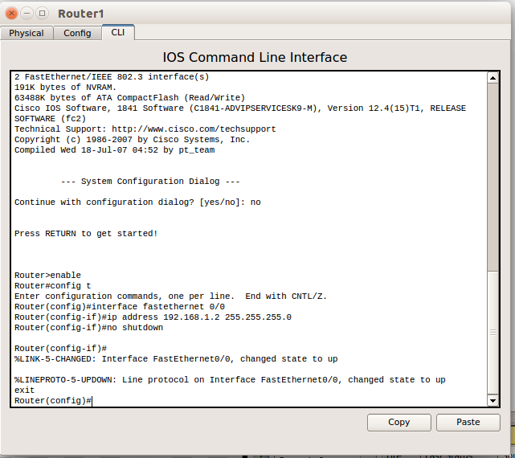

**CONFIGURE OSPF ON ROUTER R1**

R1 (config) #router ospf 1

R1 (config-router) #network 192.168.1.0 0.0.0.3 area 0

R1 (config-router) #exit

R1 (config) #exit

R1#

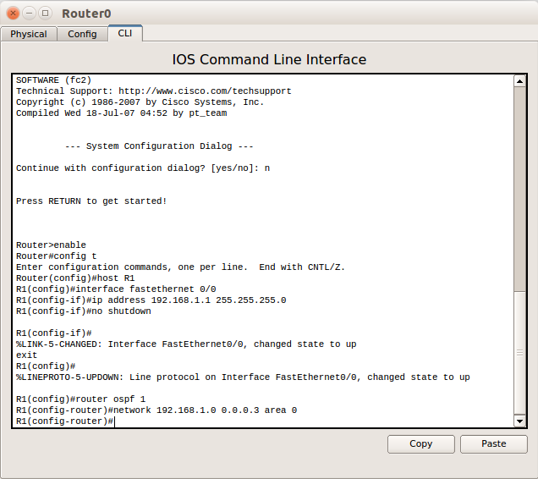

**CONFIGURE OSPF ON ROUTER R2**

R2 (config) #router ospf 1

R2 (config-router) #network 192.168.1.0 0.0.0.3 area 0

R2 (config-router) #

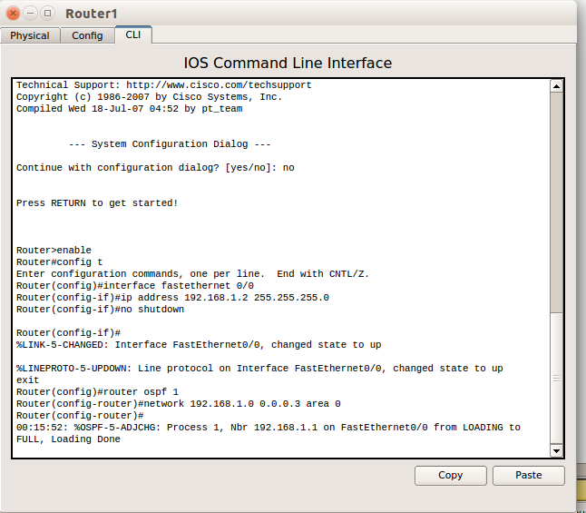

**To see the default dead time on the fa0/0 interface of router R1:**

R1#sh ipospfint fa0/0

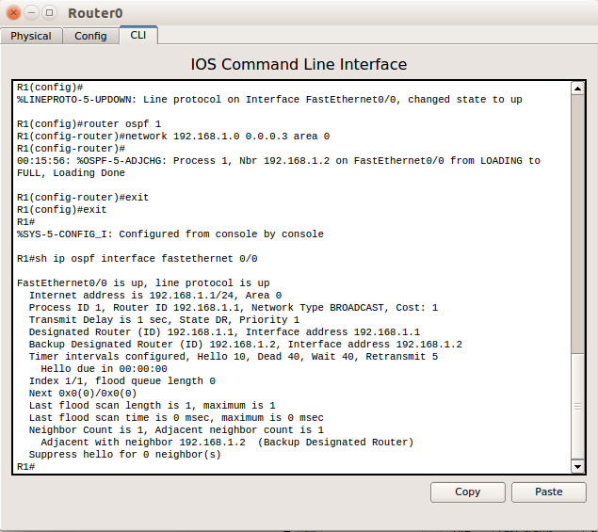

**TO CHANGE THE HELLO INTERVAL OF OSPF ON FIRST ROUTER**

R1#conf t

R1 (config) #int fa0/0

R1 (config-if) #ipospf hello-interval 10

R1 (config-if) #exit

R1 (config) #exit

R1#

R1#sh ipospfint fa0/0

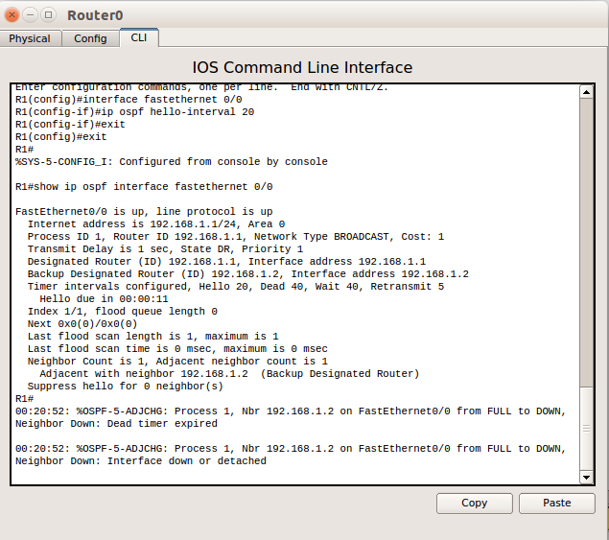

**TO CHANGE THE HELLO INTERVAL OF OSPF ON SECOND ROUTER**

R2#conf t

R2(config)#int fa0/0

R2(config-if)#ipospf hell

R2(config-if)#ipospf hello-interval 10

R2(config-if)#exit

R2(config)#exit

R2#

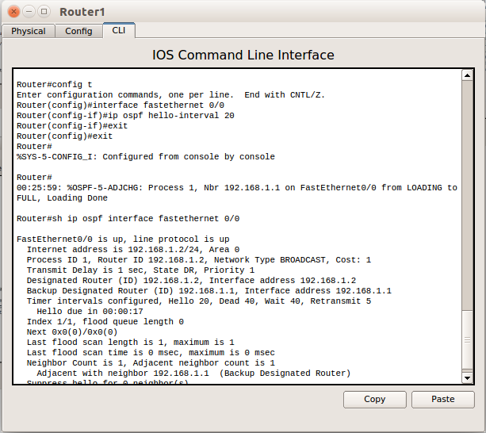

R2#sh ipospfint fa0/0